|  |
| --- |
| EXERCISES |
|

**TASK #01**

Display empno,sal of employees whose sal is less than 2000.

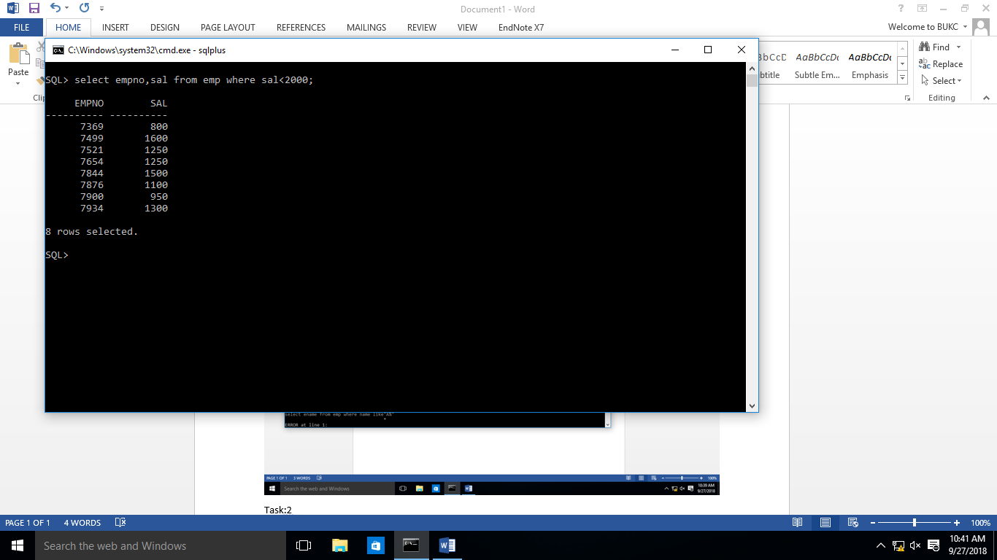

**TASK # 02**

List ename of all employees whose name starts with letter ‘A’.

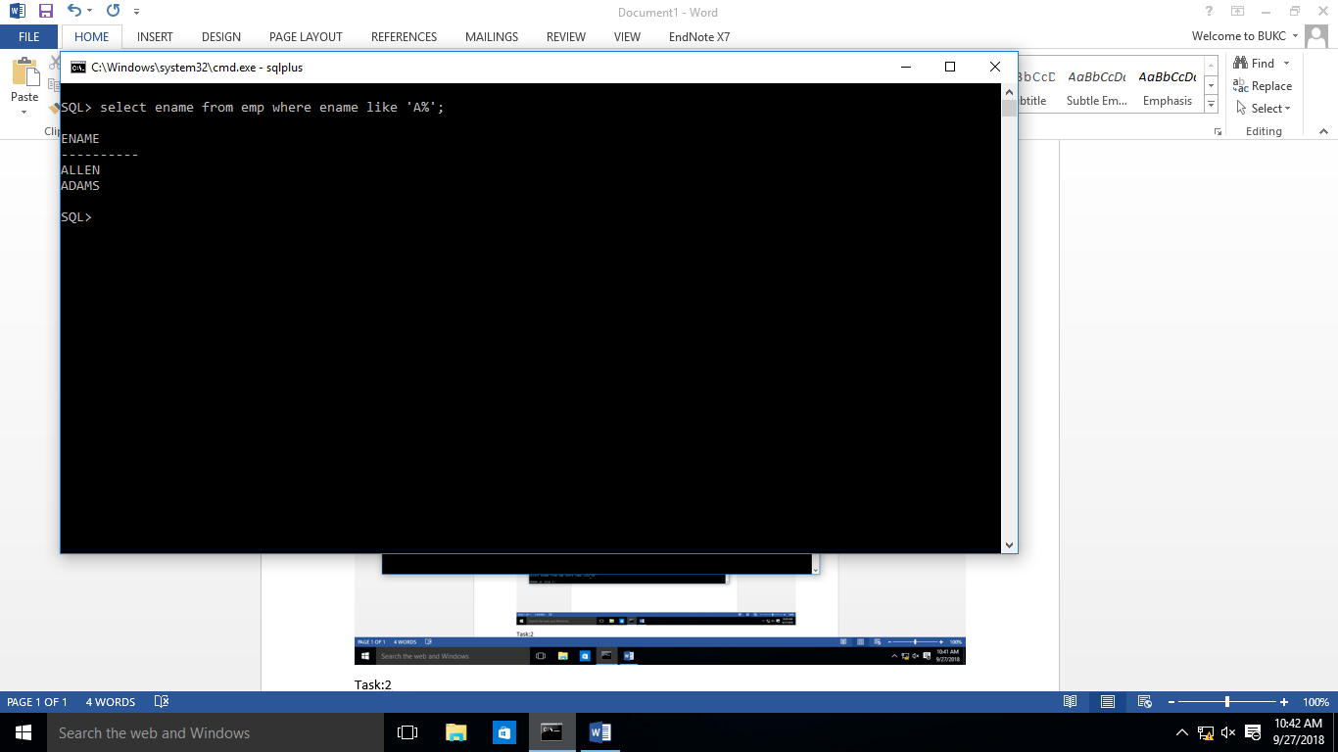

**TASK 3**

Display ename,job,deptno of employees who are either SALESMAN or belongs to deptno= 10.

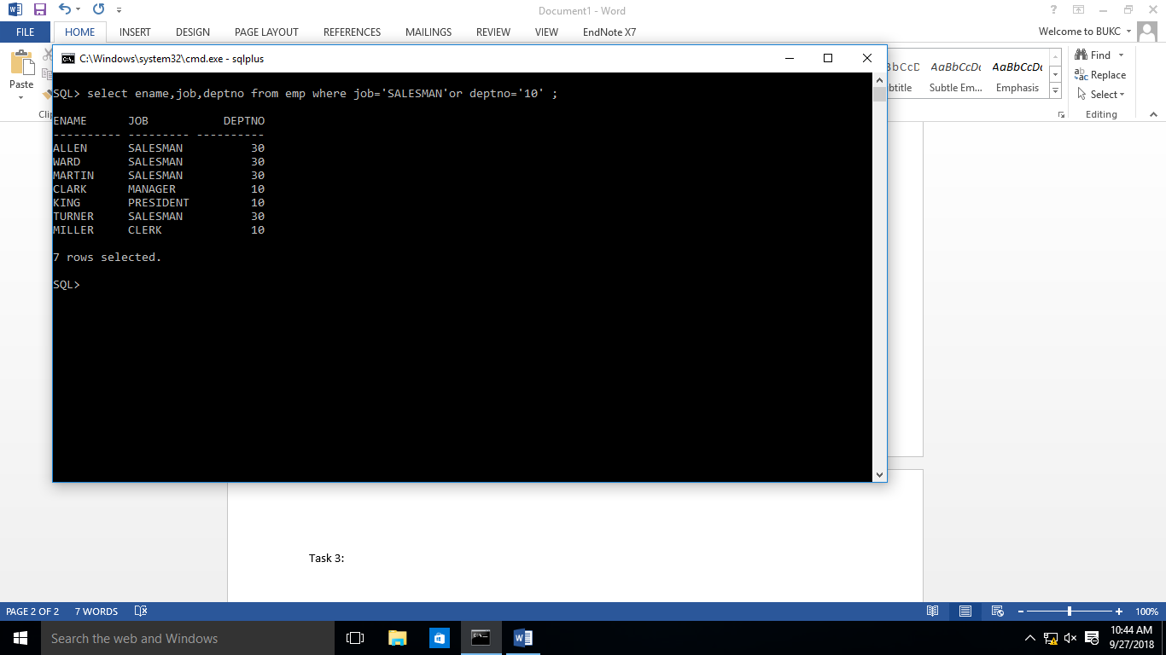

**TASK #04:**

Display ename,sal of employees whose salaries lies in the range of 1500 to 3000.

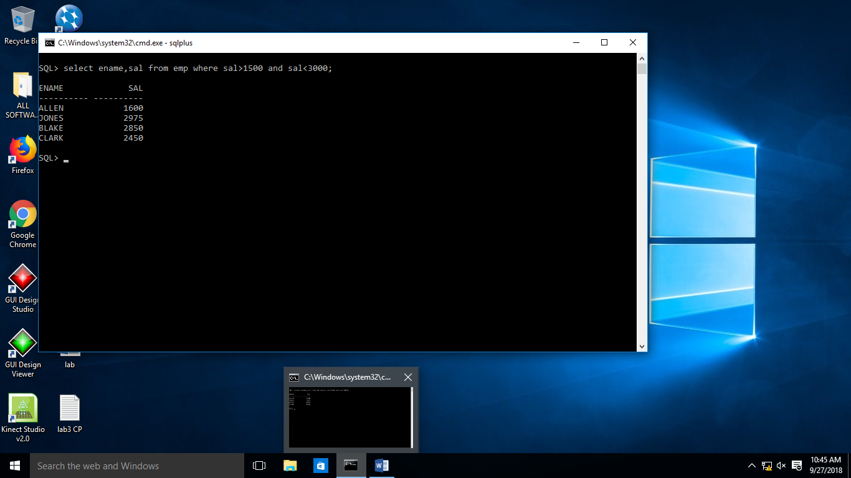

**TASK #05:**

Display ename,comm of employees whose commission is empty.

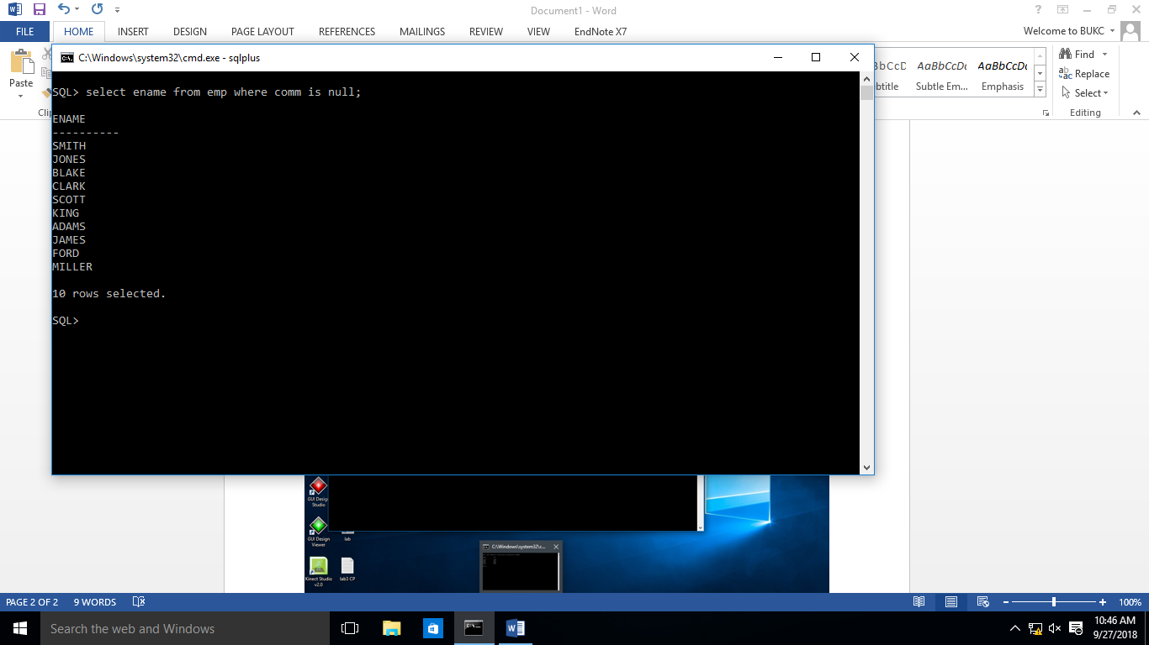

**TASK #06:**

Display names of all employees that end with alphabet ‘N’.

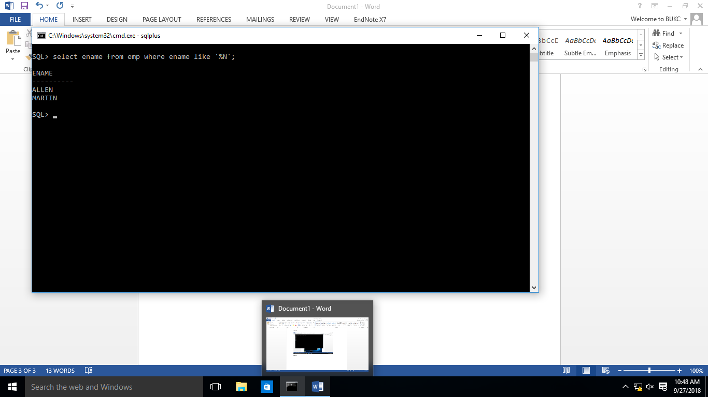

**TASK #07:**

Show ename,sal,job of those employees who are not ‘SALESMAN’.

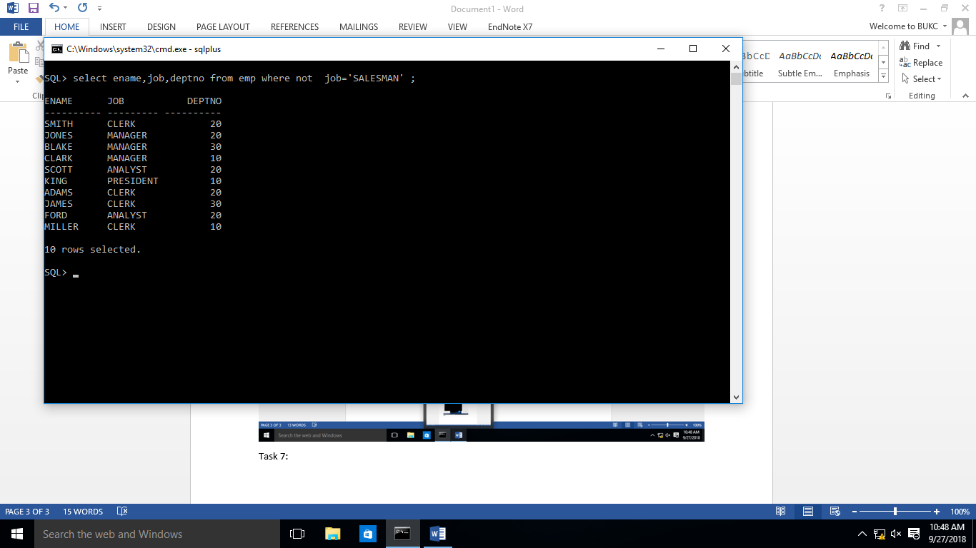

**TASK #08:**

Show empno,sal of those employees who do not have salaries of 1600, 1250, 3000.

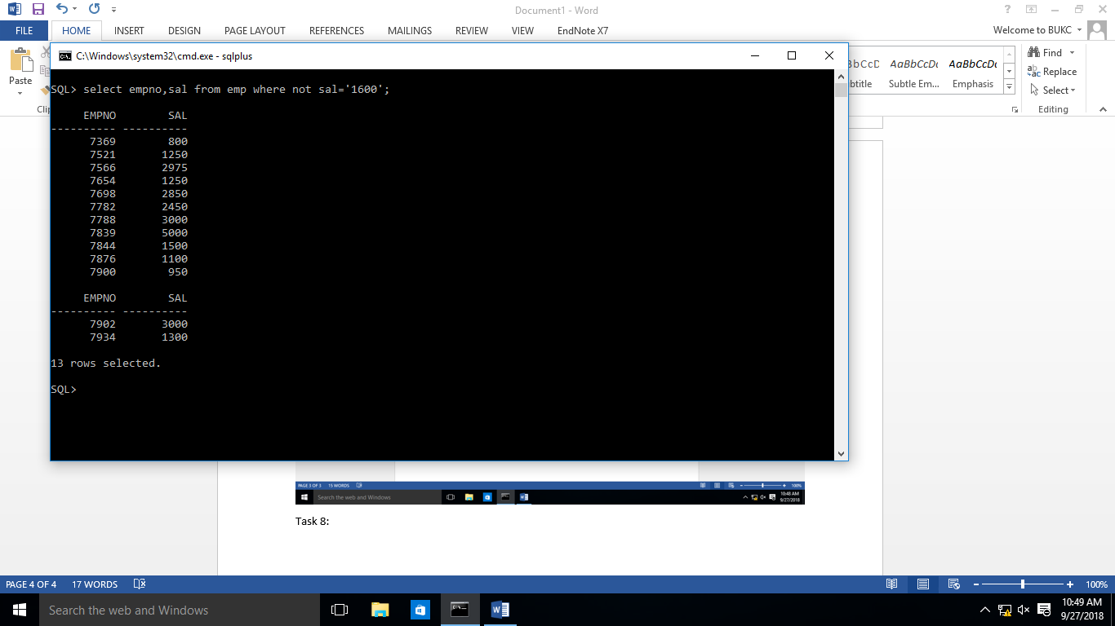

**TASK #09:**

Show names of those employees whose name starts with A and ends with N.

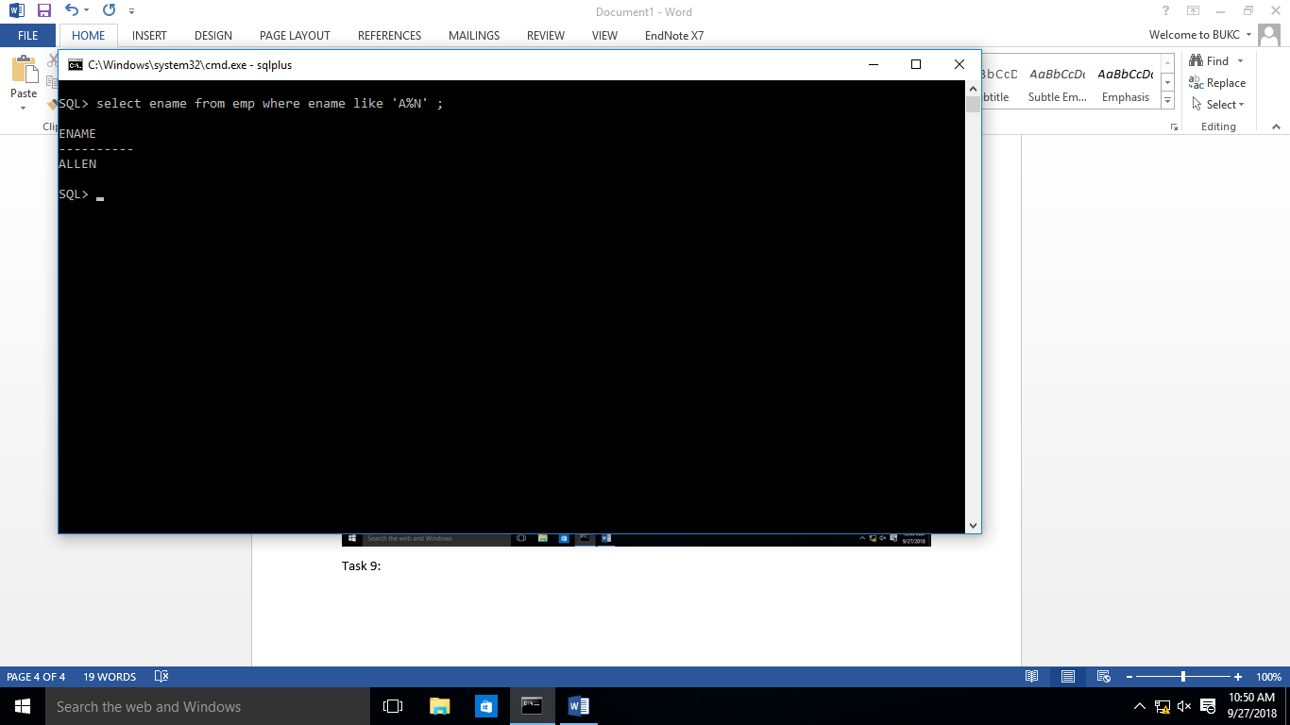

**TASK #10:**

Display the list of employee names that have letters ‘LA’ in their names.

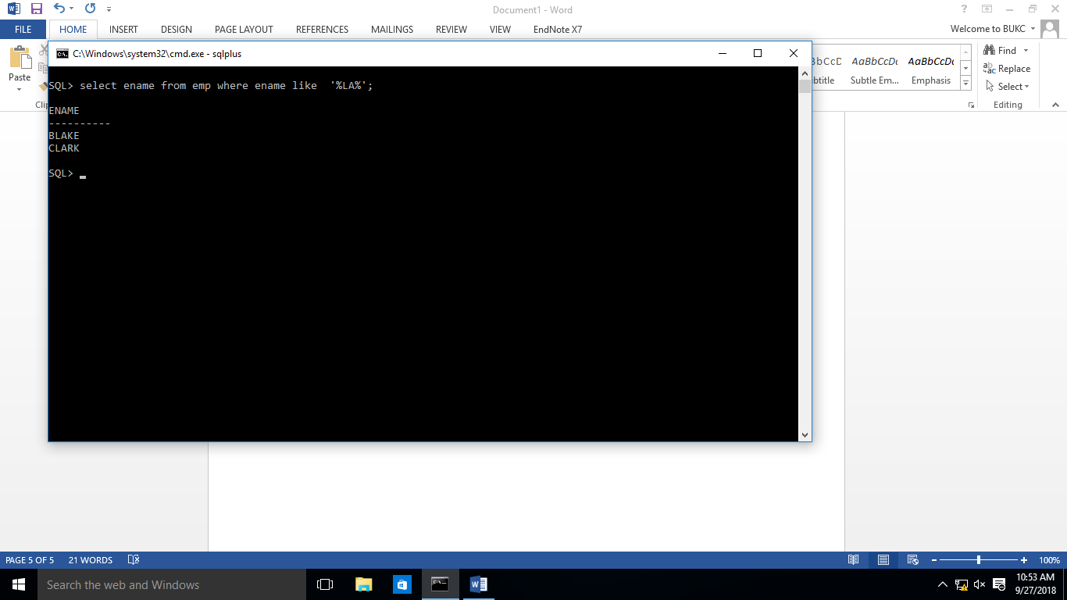

**TASK #11:**

Display the empno,sal of employees. In that, the highest paid employee should display first and lowest paid should display last.

